* 1.INTRODUCTION

When you’re learning [how to blog](https://bloggingtips.com/how-to-blog/), the right blogging apps can make all the difference. You can find apps for everything from content management to analytics to graphic design. Using a variety of apps together can help you create content and promote your blog.

Many people look for ways to expand their online presence and while one of the most popular strategies is launching a blog, not everyone knows what is a blog and how to start one.

When blogs first emerged around 1994, people used them mainly to share their personal lives, including their experiences and interests. Now, blogs have become an essential online marketing strategy for businesses and one of the most profitable career choices for individuals.

The interface of blogs has changed significantly over time. Bloggers can now integrate various widgets and plugins into their platforms, such as a social media feed, a contact form, or an author profile.

When blogs first appeared on the world wide web, their goal was mainly personal use, such as sharing stories, interests, and thoughts.

What Is the Best Blogging App?

WordPress is the best blogging app because it’s the most popular blogging platform. You can use WordPress.com with hosting or WordPress.org with separate hosting.

What Is the Best Free Blogging App?

Google Docs is the best free blogging app because it gives you a clean space to write. You can save your post drafts there in case something happens to your blog and it has an intuitive interface so everyone can jump right in.

1.1 OVERVIEW OF A BLOG APP:

The main function of a blog description is to give the searcher an idea about the content of the website. When someone searches on a search engine, the searcher wants his problem to be solved. For this, the searcher would like to visit the most relevant website only.

A blogging app is a digital tool that you can use to run your blog.Some apps allow you to write your blog posts. Other apps are better for storing content, like photos, editing photos, or collaborating with other writers for your blog.

Blogging apps are important because they can help you be more productive. Building a blog takes time and dedication. It's a long-term investment, and that includes the platform you use to create it.

This means that no matter how great a blog platform is, it needs to be right for you. It's challenging to move a blog to a new site after it gets going, so the better you prepare before you start blogging, the more likely you are to have lasting results.

Optimizing your content for search is essential to driving traffic to your blog. According to a Back link study, sites listed on the first SERP in Google get [27%](https://backlinko.com/google-ctr-stats) of all clicks for a keyword or phrase.

It's well-established that [blogging can improve SEO](https://blog.hubspot.com/marketing/blog-search-engine-optimization?hubs_content=blog.hubspot.com/marketing/best-blogging-platform&hubs_content-cta=blogging%20can%20improve%20SEO) if it's a useful resource for your customers. But SEO takes time to learn if you're just beginning your content marketing journey.

**1.2 PURPOSE OF BLOG APP:**

Nowadays, a blog is a regularly updated website or web page, and can either be used for personal use or to fulfil a business need.

For instance, HubSpot blogs about various topics concerning marketing, sales, and service because HubSpot sells products related to those three subjects -- so, more than likely, the type of readers HubSpot's blog attracts are going to be similar to HubSpot's core [buyer persona](https://blog.hubspot.com/marketing/buyer-persona-research?hubs_content=blog.hubspot.com/marketing/what-is-a-blog&hubs_content-cta=buyer%20persona).

Alternatively, a woman named Kiki started a personal travel blog, called [The Blonde Abroad](https://theblondeabroad.com/), to document her travel experiences and provide readers with helpful tips and travel recommendations. Her blog doesn't serve a larger company, but it does help her create a personal brand.

**To Educate Others and Build Online Presence**

While a blog’s function remains the same, the type of content is more diverse. While many blogs still work like online diaries, some have started blogging to educate others on a specific subject or to build a professional online presence.

For example, David Winer – author of one of the longest-running blogs, [**Scripting News**](http://scripting.com/) – publishes essays on software development, technology trends, and daily life on his personal web pages.

On the other hand, Natasha Kravchuk shares recipes and tutorials on using specific kitchen tools on her [**food blog**](https://www.hostinger.in/tutorials/how-to-start-a-food-blog), [**Natasha’s Kitchen**](https://natashaskitchen.com/). Her blog is a go-to resource for recipes, including holiday and vegetarian options.

[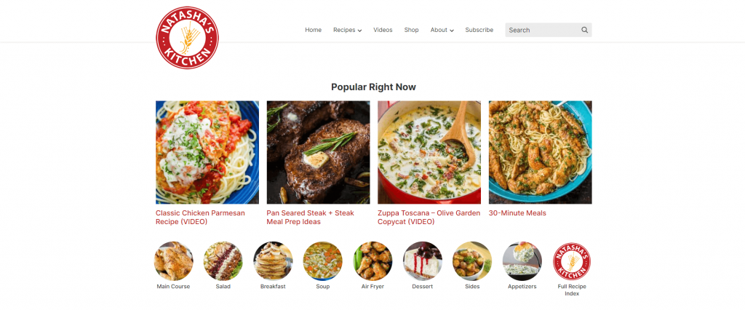](https://www.hostinger.in/tutorials/wp-content/uploads/sites/2/2022/03/natashas-kitchen-blog.png)

As previously mentioned, blogging has also become a profitable career choice, especially during the pandemic. In fact, [over 50% of blogs](https://firstsiteguide.com/blogging-industry-survey/) gained traffic, and about 35% of bloggers increased their revenue in this period.

To Help a Business with Brand Awareness

Many organizations and [businesses use blogs](https://www.hostinger.in/tutorials/how-might-a-business-use-a-blog) as part of their content marketing strategies to boost brand awareness and increase conversions.

A business’s blog content usually focuses on industry-related information that may interest its target market. Often, a team of writers runs the blog instead of a single admin.

Take a look at [Evernote’s corporate blog](https://evernote.com/blog/). It shares tips on productivity and organization, as well as how its products help optimize these processes. The brand also uses its blog to share feature and company updates.

[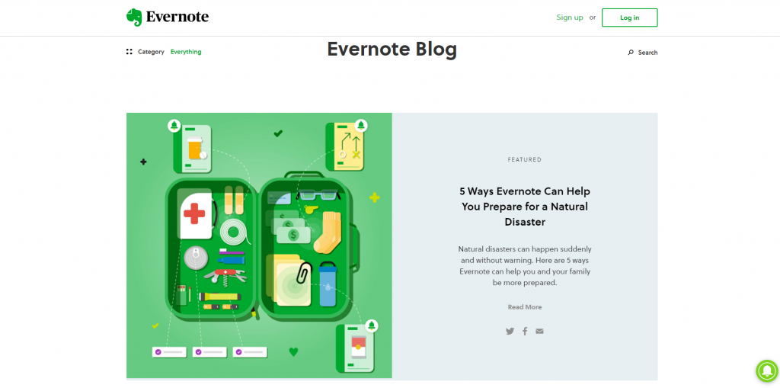](https://www.hostinger.in/tutorials/wp-content/uploads/sites/2/2022/03/evernote-blog.png)

To Promote Programs and Attract Visitors

For instance, many businesses create blogs to promote their programs in the hope of attracting more visitors and leads. We see this often with educational institutions where they try to attract more students to enrol in their programs.

[UCLA’s Bruin Blog](https://blog.admissions.ucla.edu/) is an excellent example of this practice. It tells the stories of students from different backgrounds and majors and shows how life is on campus, including events and student organizations. So people who visit their blog are compelled to enrol and join their program.

[](https://www.hostinger.in/tutorials/wp-content/uploads/sites/2/2022/03/bruin-blog.png)

2.LITERATURE SURVEY:

Web blogs, or “blogs,” are frequently updated websites where content (text, pictures, sound files, etc.) is posted on a regular basis and displayed in reverse chronological order. Readers often have the option to comment on any individual posting, which is identified by a unique URL. Through such comments and references to other online sources in the postings, as well as through links to favourite blogs in the sidebar (the “blogroll”), blogs form a clustered network of interconnected texts: the “blogosphere.”

The analytical dimension of code is most often excluded from studies, although changes in functionalities and features might have a great impact on blogging practices. To analyse the interdependencies of code and actual use, researchers should not only draw on approaches from usability studies and social informatics, but they should also consider comparative research designs to identify the consequences of various technical options for information, identity, and relationship management.

2.1 EXISTING PROBLEMS

Blogging provides anyone with the opportunity to publish content and the potential to make money. Because of this, there are hundreds or thousands of new blogs launched every day. Unfortunately, there are some significant challenges that most new bloggers face, and in many cases the challenges are significant enough to lead the blogger to give up.

In this post we’ll look at five problems that many bloggers face, especially in the early days of their blog, and we’ll also look at some ways that these problems can be overcome.

* No Comments from Visitors/Readers

It can be very frustrating to dedicate time creating a blog post, only to sit and wait for comments that never come. The interactive aspect of blogging is what draws many people to get started with their own blog, but in reality many new blogs have trouble attracting comments. If you find that your blog posts don’t usually get the attention or feedback that you had hoped for, you’re not alone.

TIPS:

1. Leave Comments on Other Blogs

When I started blogging one of the most effective ways of building an audience and attracting comments was to leave comments on other blogs. I focused on other small blogs rather than industry leaders, because those bloggers were more likely to notice and appreciate the comment, and sure enough, many of them came to my blog and returned the favor.

1. Write Thought-Provoking Posts or Cover Controversial Topics

Certain types of blog posts tend to attract more comments than others. Anything that makes readers think and encourages them to form and share an opinion will be more likely to receive comments. I’m not a big fan of writing controversial posts intentionally just to get attention, but many bloggers have used this approach to increase their exposure and it can lead to a lot of comments.

* 2. Not Enough Traffic

Possibly the most frustrating challenge for many bloggers is trying to attract more visitors. In fact, most bloggers don’t give very much thought to how they will attract visitors until after the blog has been launched and they find that not many people are visiting.

TIPS

1.Re-Evaluate Your Posts

Take a step back and look at the types of posts that you are publishing to make sure that you’re providing original content that is worthy of attention. What other types of posts could you try? How could you differentiate yourself from other blogs in the industry/niche? Are your posts working together to develop the style that you are hoping to achieve? Are certain types of posts having more success than others?

2.Write Guest Posts for Other Blogs

Probably my favourite method of promoting a new blog is to write posts that are published on other blogs. There are tons of blogs out there that are looking for quality content, so getting your articles published isn’t that difficult, but it does take some time.

* **3.No Clear Purpose**

Every blog should have a clear purpose. If you’re maintaining a personal blog your focus is probably just to communicate with friends and family, so you can pretty much post whatever you want. But if you are blogging for business purposes you should have an idea of what you want to get out of blogging. Many people start blogs because other people are doing it and they feel that it is important, but they don’t always know specifically why.

**TIPS**

1.Think About Why You Want to Blog

Do you want to blog simply to share your thoughts and opinions? Do you want to use the blog to promote your services? Do you want to sell products? Do you want to build your reputation and position yourself as an expert? Do you want to make money from affiliate products or ad clicks?

2.Be Consistent with Promotion

In addition to posting on a regular schedule, it can also help to consistently promote your posts in the same places. If you consistently submit your posts to the same social media sites, other users of those sites will get used to seeing your content there, and they’ll be more likely to view your blog as a leading source of content in the industry. Rather than submitting each post to somewhere different, try to build some connections with other users of the sites where you are promoting your content on a regular basis.

* **4.Very Few Repeat Visitors:**

While getting traffic is certainly a concern for many bloggers, repeat traffic really is what is most important to a blog’s long-term success. The community of users are people who come to the blog on a consistent basis, hopefully they leave comments at least occasionally, and they’re also more like to share a link or vote for the content on social media sites.

**TIPS:**

1.Encourage Subscriptions by Email and RSS

One of the best ways to get readers to come back is if they subscribe by RSS or email. Subscribers will see your content any time something new is posted, so it’s very likely that they will see something they like in their RSS reader or email inbox and return to your site.

2.Have a Customized Blog Theme

Part of attracting repeat visitors is branding your blog and making sure that it sticks out in their mind. In the future when they are looking for information on a topic relevant to your blog hopefully you will come to mind. Branding yourself and standing out from other blogs in your niche is easier when you have a custom designed theme that is unique to you

**2.2PROPOSED SOLUTION:**

If you’re not blogging for personal reasons you most likely want to make money from your blog either directly or indirectly. Although the potential to make money blogging is rather high, in reality only a small percentage of bloggers ever achieve their income goals.

* **Don’t Expect to Make Money Right Away**

Building a profitable blog takes time. It’s extremely rare that a new blog will produce any significant income in the first few months, or even the first year in many cases. Many bloggers expect to see results very quickly, and they get discouraged even though they are making great progress simply because income is low.

* **Have a Plan**

How do you want to make money with your blog? There are a lot of different possibilities, and we touched on several of them earlier when we talked about having a purpose for your blog. Some common ways to make money with your blog include: ad sales, AdSense, affiliate products, memberships, premium content, product sales, and promoting services.

* **Don’t Rely Only on One Source of Income**

For the best income potential and security, you should attempt to generate revenue from a few different sources. This is especially true as your blog grows and more income opportunities arise, and it’s also more applicable if you intend for blogging to become your primary source of income.

**3.THEORITICAL ANALYSIS:**

*Blog Theory* offers a critical theory of contemporary media. Furthering her account of communicative capitalism, Jodi Dean explores the ways new media practices like blogging and texting capture their users in intensive networks of enjoyment, production, and surveillance. Her wide-ranging and theoretically rich analysis extends from her personal experiences as a blogger, through media histories, to newly emerging social network platforms and applications.  
In remarkably clear and lucid prose, Dean links seemingly trivial and transitory updates from the new mass culture of the internet to more fundamental changes in subjectivity and politics. Everyday communicative exchanges from blog posts to text messages have widespread effects, effects that not only undermine capacities for democracy but also entrap us in circuits of domination.

**3.1 BLOCK DIAGRAM:**

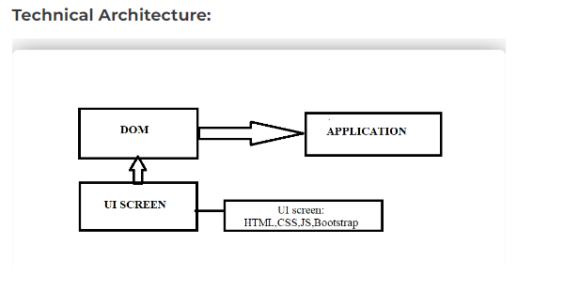

The blog app is a web application that provides real-time blog posts. Based on products, Solutions, New technologies, New projects, and Management. The blog app is fully responsive. The blog is made using Java script, CSS, HTML, and Bootstraps. The central theme of the blog is to show new ideas and new innovations on one website.

3.2 Hardware / software designing :

The technical requirements for blogging software are much more specific than what you'd need for a typical Web site. Most blog software use a mix of several kinds of Web server technology that are ideal for running dynamic Web sites like blogs. The following technologies are considered the bare minimum that most blogging packages need to function:

* **Linux:** Linux is a common Web server operating system. This stable operating system is considered a standard for Web servers. As a blogger, you won’t be doing too much to the operating system, as long as it’s in place for you.
* **Apache:** Apache is Web-page-serving software, which means it looks at what Web page is requested and then feeds the browser the appropriate file. It does most of the hard work of serving Web pages to visitors coming to your Web site.
* **MySQL:**MySQL is the most popular database software for blogs. For any blogging package, you need some kind of database system to store all your blog posts and run the other functionality of the blog software.
* **PHP:** PHP is the programming language that a lot of blogging and content management systems use. It sits between the blogging software and the database, making sure all the parts work together.

Consider these requirements as well:

* **Disk space:** For blogging, disk space is important if you decide to store a lot of images on your blog or to upload audio and video files. Uploading images is relatively easy to do, but you need the space to store those images. For the average blog with a few photos, you most likely want about 500MB. Blogs that have a lot of photos require several gigabytes (GB) of disk space. Video blogs need a whole lot more disk space (unless you’re using an online video-sharing service) and you want more than 10GB.
* **E-mail management:** You’ll want an e-mail address with your new domain. If you want to use your blog for business purposes, having an e-mail address that matches your domain is highly recommended. Strong e-mail offerings and management tools are signs of a good Web host.
* **Backups:** Consider how you’ll be backing up your data (including your database content) and how the files on your Web-hosting account will be backed up. Knowing this information can save you from disaster and data loss in the future.
* **Bandwidth and CPU Resources:** Computers and networks can take only so much load, and hosts usually set a quota on how much bandwidth you can use for the size Web-hosting package you buy. Ask about what happens if you exceed your monthly allowance of bandwidth.

**4.FINAL RESULT:**

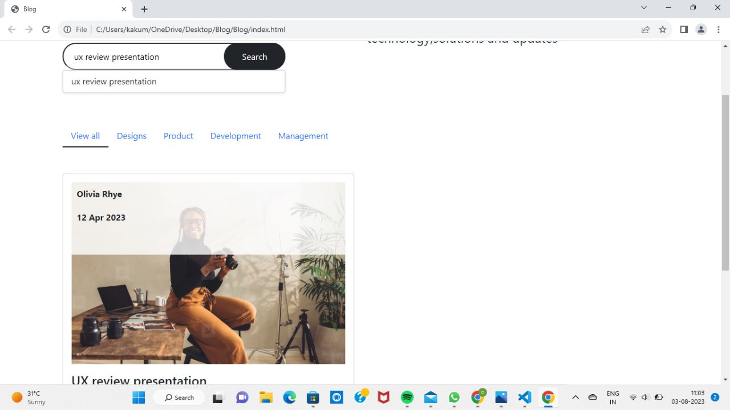

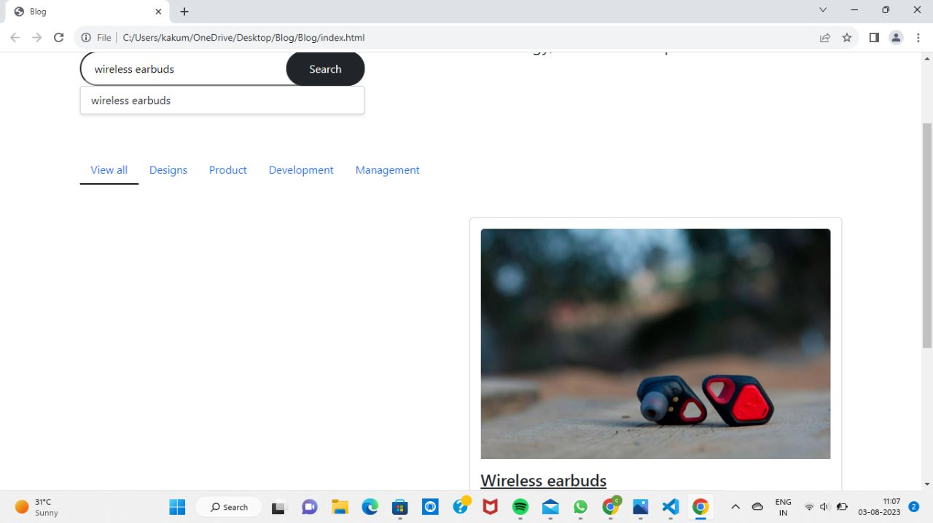

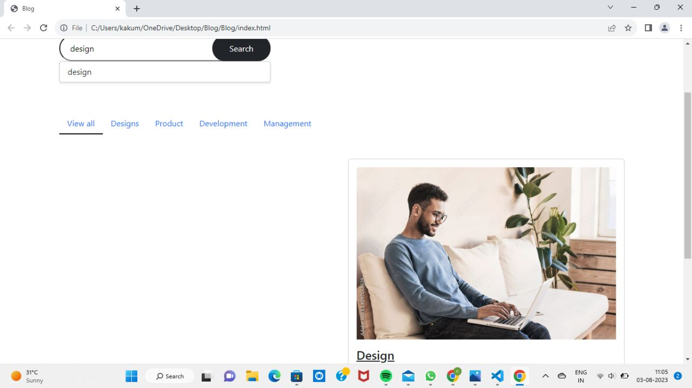

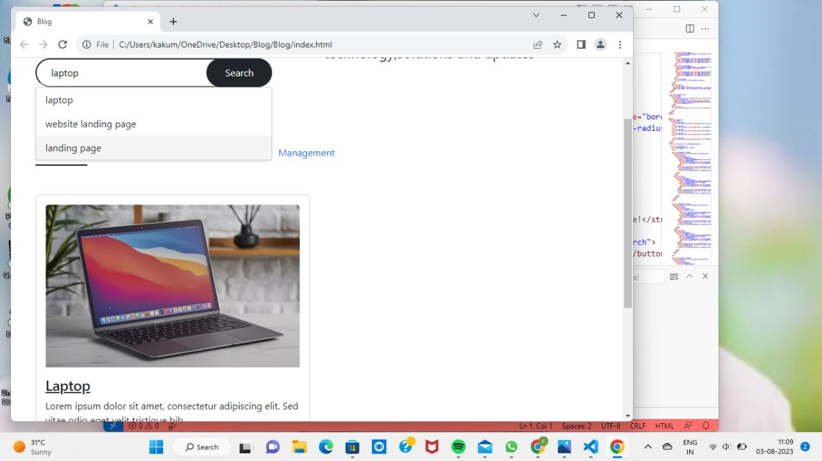

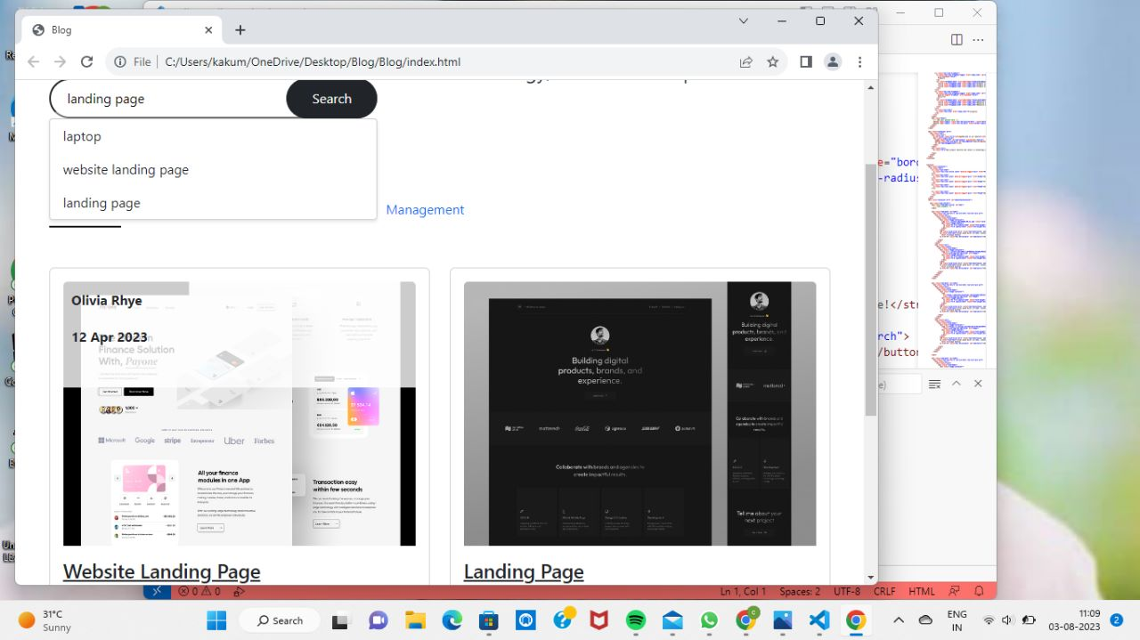



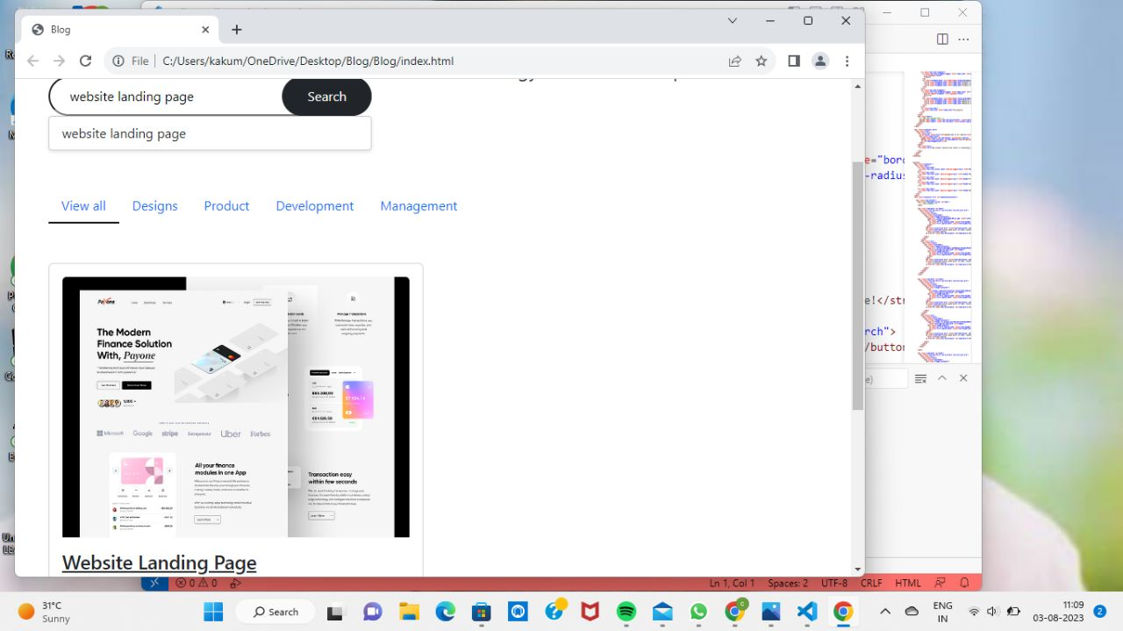

**5.ADVANTAGES &DISADVANTAGES OF BLOG APP:**

**ADVANTAGES:**

Blogs are a big source of information used by the majority for sharing and receiving information. The following are various advantages of the blog:

**1. SEO (Search Engine Optimization)**

This feature assures the presence of good content on blogs. As good content becomes a necessity to be recognized.

**2. Opportunities**

Anyone who aims to generate revenue can easily start by producing good content and attracting an audience.

**3. Personal Development**

There is a big possibility of personal development. By writing posts, one can get feedback from a large number of people from all around the world.

**4. Personal Influence and User Analysis**

Large companies spend a huge amount on consumer feedback, whereas here, we get that for free. By working on posts for blogs, if we create good content, a large number of visitors get attracted.

**DISADVANTAGES:**

While building a blog app can be a great idea for various reasons, there are also some disadvantages and challenges that developers and users may encounter. Here are some of the disadvantages of building a blog app:

**1. Development Complexity:** Building a blog app can be more complex than it seems, especially if you want to include advanced features like user authentication, comments, search functionality, and more. Ensuring a smooth and intuitive user experience can require significant development effort.

**2. Security Concerns:** Blogs can be vulnerable to various security threats, such as SQL injection, cross-site scripting (XSS), and other attacks. Developers need to implement robust security measures to protect user data and prevent unauthorized access.

**3. Maintenance Overhead:** A blog app requires regular maintenance and updates to keep it running smoothly. As technologies evolve, you may need to update dependencies, plugins, and frameworks to ensure compatibility and security.

**4. Performance Issues:** If not optimized properly, a blog app can suffer from performance issues, leading to slow loading times and a poor user experience.

**5. Content Moderation:** If your blog app allows user-generated content, you'll need to implement content moderation mechanisms to prevent spam, offensive content, and inappropriate material from being published.

**6. Monetization Challenges:** If your blog app is intended for monetization, generating revenue from a blog can be difficult, especially if you rely solely on ads. It can take time to build a large enough audience to attract advertisers or develop alternative revenue streams.

**7. SEO and Discoverability:** Getting your blog app noticed in the crowded online space can be challenging. Search Engine Optimization (SEO) techniques and marketing efforts are necessary to improve the blog's discoverability and attract organic traffic.

**8. Mobile Responsiveness:** With a significant portion of internet users accessing content through mobile devices, ensuring that your blog app is fully responsive and works well on different screen sizes is crucial.

**9. Competition:** The blogosphere is vast and highly competitive. Gaining visibility and establishing your blog as a reputable source in your niche can be tough.

**10. Server Costs:** Hosting a blog app with a considerable amount of traffic can be costly, especially if you opt for high-performance servers or cloud services to handle the load.

Despite these disadvantages, building a blog app can also offer numerous benefits, such as fostering a community, sharing valuable information, showcasing expertise, and contributing to personal or business branding. The key is to be aware of the challenges and plan accordingly to address them effectively.

**6.APPLICATIONS OF BLOG APP:**

Building a blog app has a wide range of applications and can serve various purposes. Here are some of the main applications of building a blog app:

1. Personal Blogging: Individuals can use blog apps to create personal blogs where they can share their thoughts, experiences, and interests with others. It allows them to express themselves and connect with like-minded people.
2. Business Blogging: Many businesses use blog apps to create and manage their company blogs. They can use the blog to showcase their products or services, provide valuable content to their customers, and improve their online presence.
3. Content Marketing: Content marketing is a strategy used by businesses to attract and engage potential customers. Blog apps provide a platform to create and share valuable content, such as articles, guides, and tutorials, to attract and retain an audience.
4. News and Media: News organizations can use blog apps to publish and distribute news articles, feature stories, and opinion pieces. It allows them to reach a broader audience and keep their readers updated with the latest information.
5. Educational Purposes: Educational institutions can create blog apps for students and teachers to share knowledge, research, and educational resources. It can enhance collaboration and foster a learning community.
6. Niche Communities: Blog apps can cater to specific niches and communities, such as fashion, fitness, technology, cooking, travel, etc. It allows enthusiasts to connect, share, and discuss their interests.
7. Journalistic Reporting: Journalists can utilize blog apps to report on events, stories, or investigative pieces that may not be covered by mainstream media. It provides them with a platform to express their perspectives.
8. Portfolio Showcase: Artists, photographers, writers, and other creatives can use blog apps as a platform to showcase their work and build a professional portfolio to attract potential clients or employers.
9. Personal Branding: Entrepreneurs, professionals, and influencers can leverage blog apps to build their personal brand. It helps in establishing authority, networking, and attracting opportunities.
10. Community Building: Blog apps can serve as a central platform for building and nurturing online communities. It allows users to engage in discussions, share ideas, and connect with others who share similar interests.
11. Hobby and DIY Projects: Enthusiasts of various hobbies and DIY projects can use blog apps to document their experiences, share tips, and provide guidance to others interested in the same hobbies or projects.
12. Guest Blogging: Blog apps can facilitate guest blogging opportunities, where writers can contribute their content to expand their reach and build their reputation within a specific niche.

**7.CONCLUSION:**

The conclusion of building a blog app can be summarized as follows:

1. Achievement of Goals: Building a blog app is a significant undertaking, and the conclusion marks the successful completion of the project's goals and objectives. It signifies that the app has been developed, tested, and deployed as planned.

2. Functionality and Features: The blog app should now be fully functional, allowing users to create accounts, publish blog posts, comment on posts, and interact with other users. All intended features and functionalities should be implemented and working as expected.

3. User Experience: A well-designed blog app should provide a seamless and enjoyable user experience. The app's interface should be intuitive, visually appealing, and easy to navigate, ensuring that users can use it without any significant hurdles.

4. Testing and Bug Fixing: The app should have undergone rigorous testing to identify and resolve any bugs or issues. Quality assurance measures should have been taken to ensure that the app performs optimally across different devices and browsers.

5. Security and Privacy: Building a secure blog app is crucial to protect users' data and maintain the integrity of the platform. Security measures should have been implemented, such as encryption, secure authentication, and protection against common vulnerabilities.

6. Deployment: The blog app should have been successfully deployed to a production server or hosting environment, making it accessible to users over the internet.

7. Future Development: The conclusion of building a blog app does not mean the end of its development. Ongoing maintenance, updates, and improvements may be necessary to address user feedback, fix issues, and add new features in response to changing requirements.

8. Launch and Promotion: With the app now ready, a launch and promotional strategy may be deployed to attract users and grow the blog's readership.

In conclusion, building a blog app is an exciting and rewarding endeavour that requires careful planning, development, and attention to user experience and security. The conclusion marks the start of a new phase in the app's lifecycle, where continuous improvement and growth are the key focus.

**8.FUTURE SCOPE OF BLOG APP:**

The future scope of building a blog app is vast and promising, with opportunities for growth and expansion in various directions. Some potential areas of development and enhancement include:

1. Content Personalization: Implementing AI-driven algorithms to personalize content recommendations for users based on their interests, reading history, and behaviour. This can enhance user engagement and satisfaction.

2. Multimedia Integration: Allowing users to embed multimedia content like videos, podcasts, and interactive elements in their blog posts to make the platform more dynamic and appealing.

3. Collaborative Features: Introducing collaborative features that enable multiple authors to contribute to a single blog post or allow users to collaborate on content creation, fostering a sense of community and teamwork.

4. Mobile App Development: Expanding the blog app's reach by developing mobile applications for both Android and iOS platforms. Mobile apps can enhance user accessibility and convenience, leading to increased user engagement.

5. Social Media Integration: Integrating with popular social media platforms to enable seamless sharing of blog posts and attracting new users from social media channels.

6. Monetization Options: Exploring monetization avenues, such as ad placements, sponsored content, subscription models, or affiliate marketing programs, to generate revenue for the app and its content creators.

7. Community Building: Building a strong community around the blog app through features like user forums, commenting systems, and engagement initiatives. A thriving community can drive user retention and attract new users through word-of-mouth.

8. Analytics and Insights: Incorporating robust analytics tools to provide content creators with detailed insights into user behaviour, popular topics, and engagement metrics. This data can help them tailor their content and improve overall performance.

9. Offline Access: Implementing offline access capabilities, allowing users to save and read blog posts even when they are not connected to the internet.

10. Localization and Internationalization: Offering support for multiple languages and cultural preferences to attract a global user base and reach a broader audience.

11. Accessibility: Ensuring the blog app complies with accessibility standards, making it usable for individuals with disabilities and expanding its inclusivity.

As the digital landscape evolves, staying adaptable and receptive to emerging trends and technologies will be essential for the future success of the blog app. By continuously innovating and offering a delightful user experience, the blog app can remain relevant and thrive in a competitive online ecosystem.